JavaScript Object

Object in javascript can also be considered as dictionary as in python. It contains key-value pair.
Key of any object should be unique and values can be duplicate. We can get data of the object as follows.:

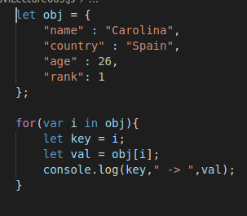

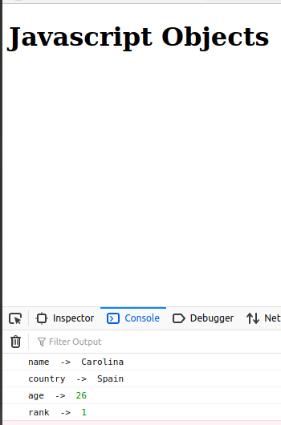

Objects has their own rules as follows.
1) No key duplication.
2) Keeping track of order of elements is not necessary.
3) You can have list of objects.

Eg. This example of list of objects and printing any specific character of the objects.

